User manual

Hardware Requirements:

Verify your system meets or exceeds the minimum hardware requirements:

* Java version 1.4.0 or greater
* 800MHz Intel Pentium III or equivalent
* 512MB Ram
* 750MB of free disk space
* Administrator privileges on your system

Download Eclipse Oxygen 64-bit.

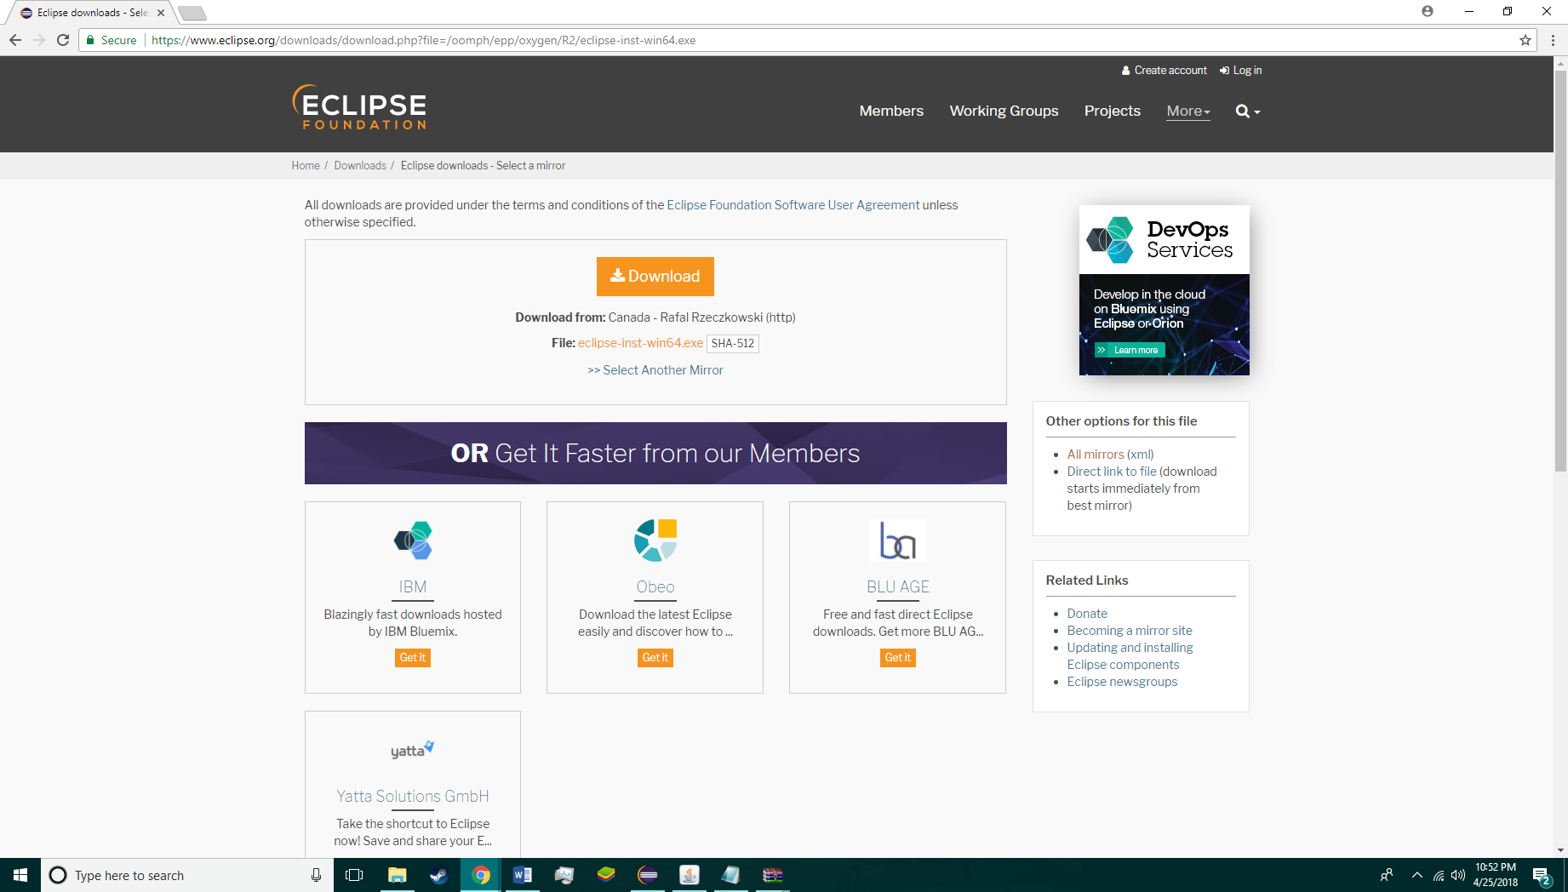

Run Eclipse Installer.

Select Eclipse IDE for Java Developers.

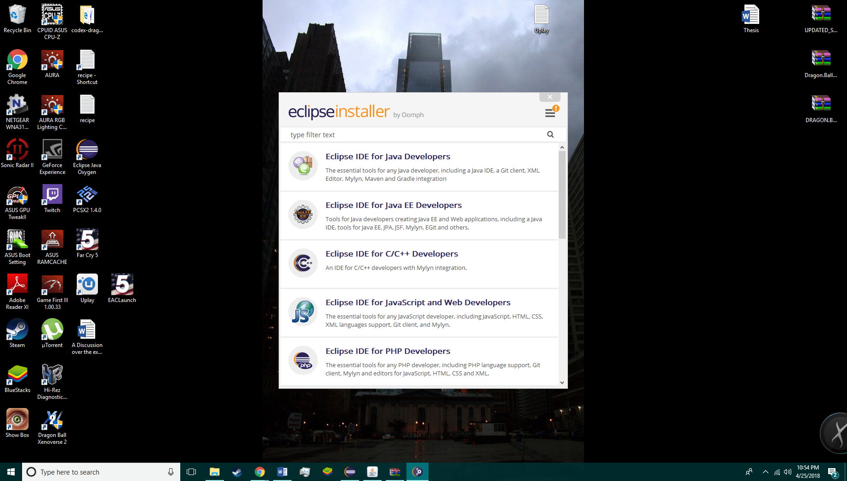

Click Install.

Once installed run Ecilpes

From the main menu bar, select **File > Import**. The Import wizard opens.

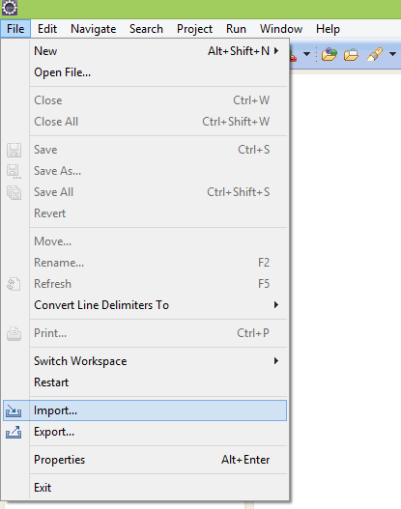

Collapse or click **+** in **General > Existing Project into Workspace** and click **Next**

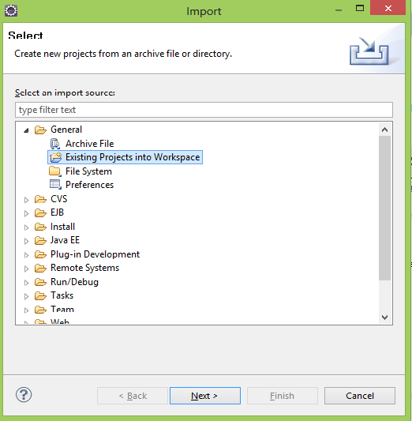

Under **Projects** select the project containing our files.

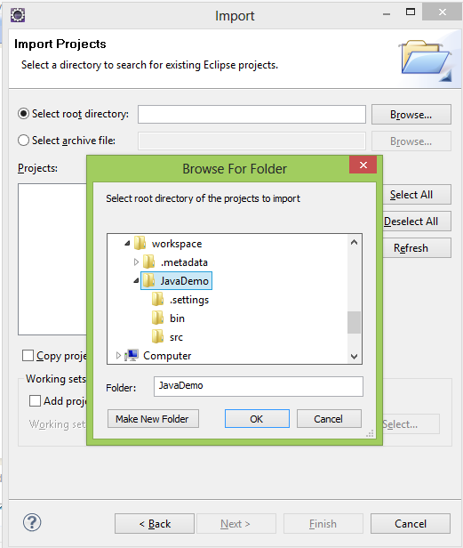

Click Finish to start the import

Click run to start the file

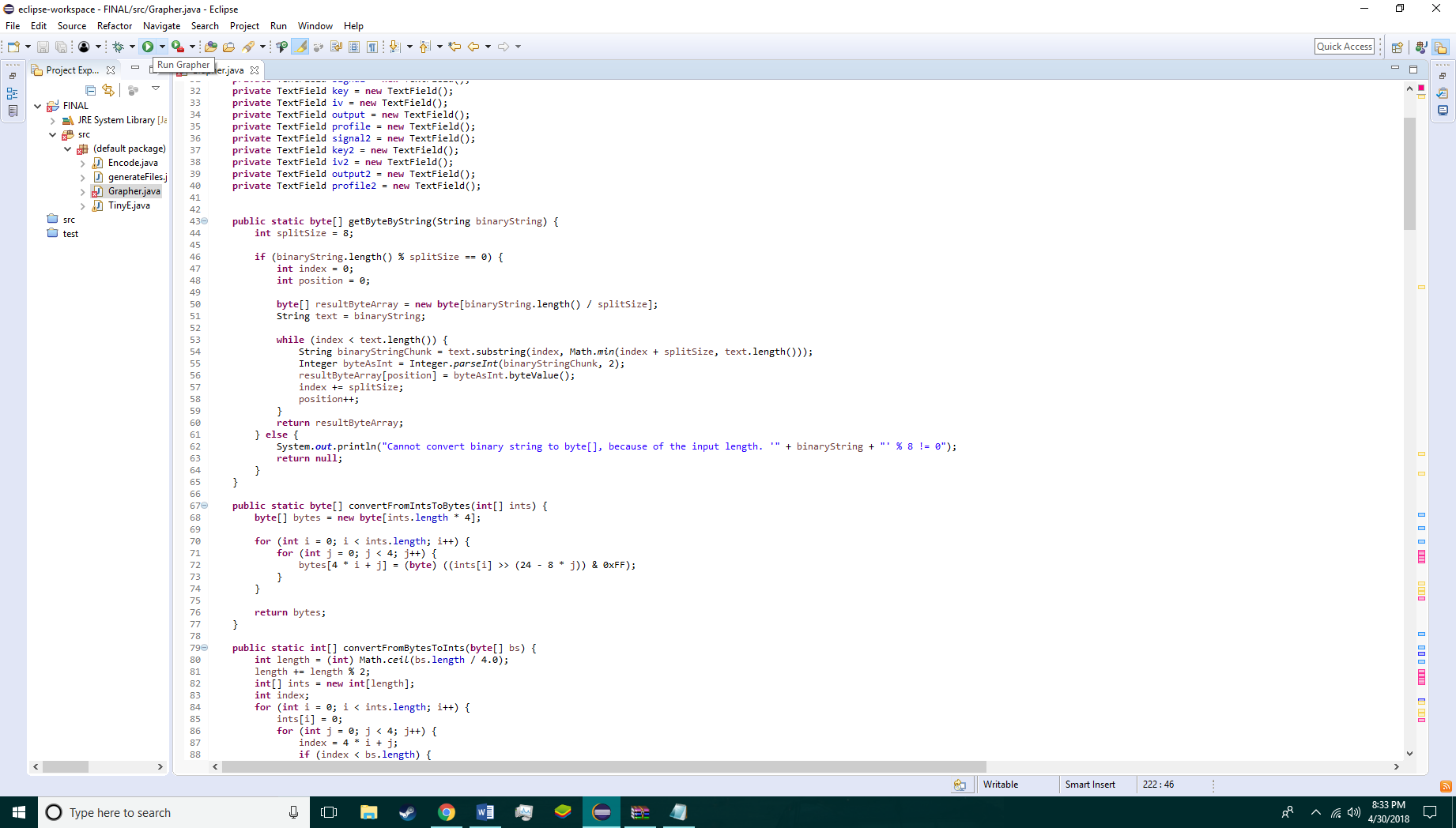

Enter the file names, and press encrypt to receive the output and graph

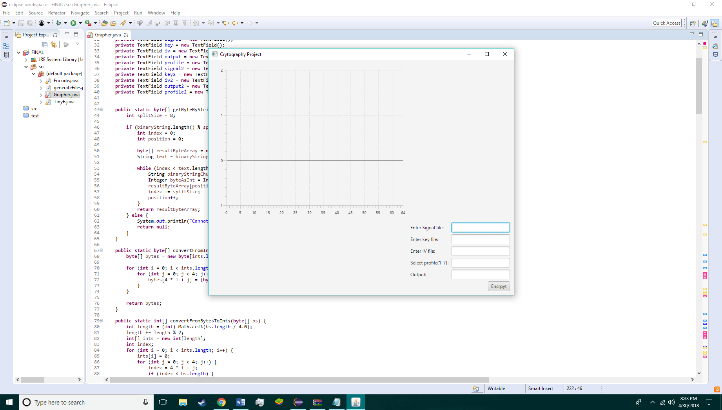

Enter the encrypted file names, and press decrypt to receive the output and graph.